**Welcome to A-level Sociology!**

You have chosen a subject that will ‘keep you on your toes’ and make you think in ways you couldn’t imagine. You will certainly have a very different outlook on society by the end of your course.

**Overview of the course:**

This is a two-year course which ends with **three** two-hour papers each carrying an equal weighting towards your final A-level grade (A*-E).

Topics we will cover will include:

Year 12 Year 13

Introduction to Sociology Beliefs in Society

Education Theories of Sociology

Research Methods Crime & Deviance

Families & Households

Look at the specification for more detail about these topics. You can find this at: <https://filestore.aqa.org.uk/resources/sociology/specifications/AQA-7191-7192-SP-2015.PDF>

You will be expected to know and understand **(AO1)** the information about the topics, to be able to apply **(AO2)** that knowledge and understanding and to be able to analyse and evaluate **(AO3)** that knowledge and understanding.

**Expectations of the course:**

* Every lesson you will be given a set of notes which will contain all the content you need. You will be expected to file these notes in a folder, which you will need to keep organised.
* Lessons consist of annotating class notes, lots of discussions, watching relevant documentaries and PowerPoint presentations.
* Homework consists of wider reading, research, past exam questions, and essays. It is expected that about 5 hours a week will be spent on Sociology homework.
* The list below will give you an idea about who to follow on Instagram to get more of a flavour of the subject.
* @thesociologyguy
* @tutor2usoc
* @everydayracism_
* @simplepolitics
* @laura-bates__
* @the_female_lead

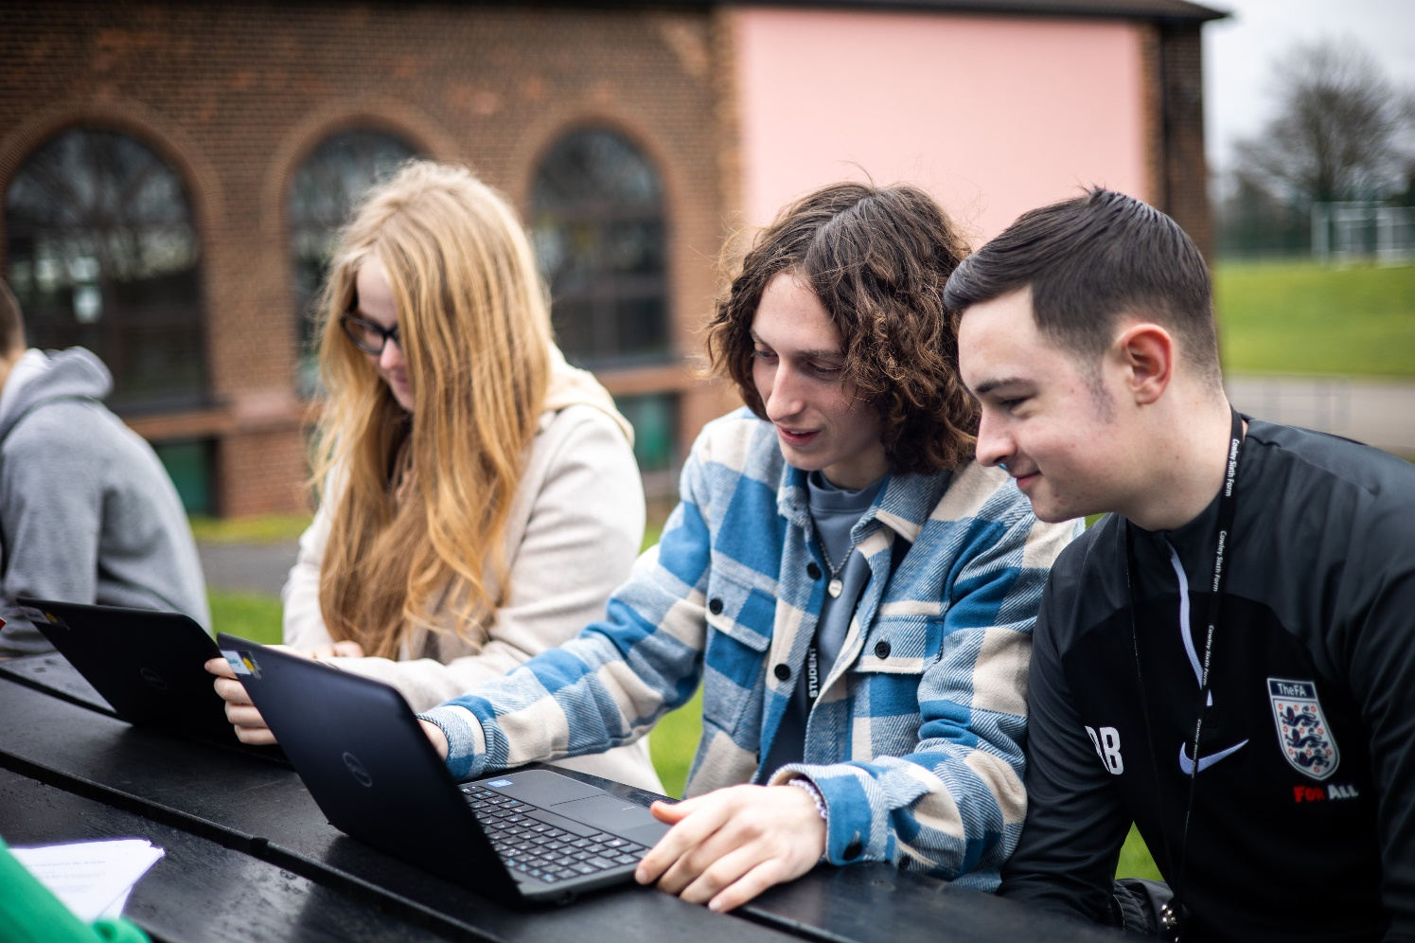

**An introduction to A Level Sociology**

**Sociology** is the study of human social life. There are many different aspects of Sociology to address, so you must be curious and attentive to looking at the world in a different way!

[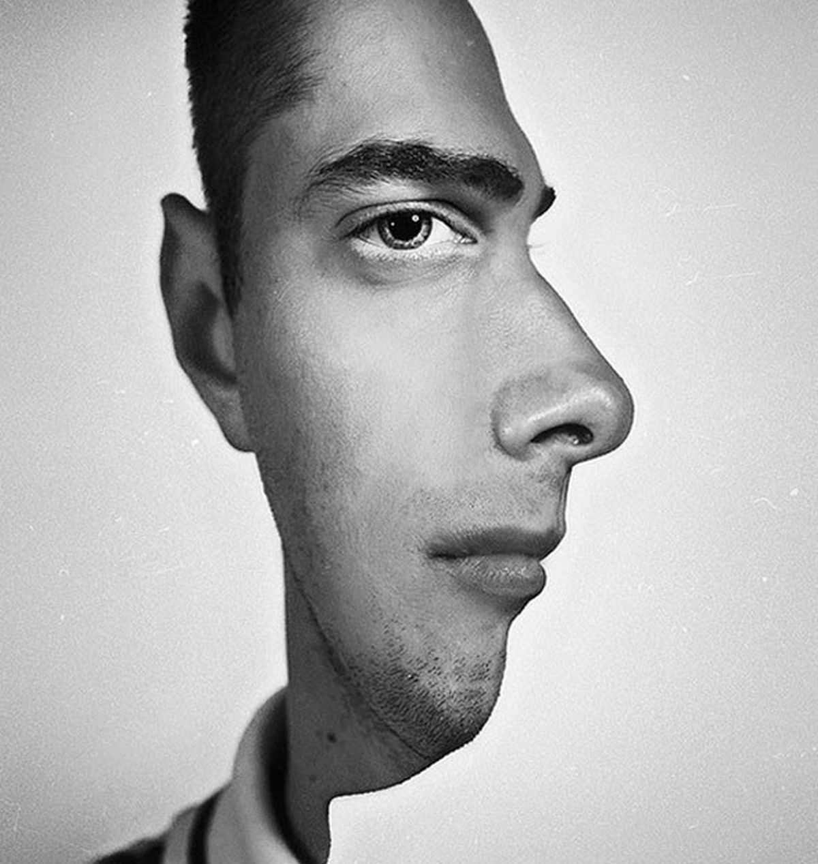](https://www.google.co.uk/url?sa=i&rct=j&q=&esrc=s&source=images&cd=&cad=rja&uact=8&ved=2ahUKEwjigqiopOLbAhVMVxQKHWZzBw0QjRx6BAgBEAU&url=https://www.seenox.org/incredible-visual-illusions-will-make-you-feel-like-on-drugs/&psig=AOvVaw3FBeiv_qt64EG9G-NAIyRO&ust=1529585523353145)

Look at this photograph; not everything is as it seems!

There is usually another way of looking at things – and that is what we do as sociologists.

We take normal, taken-for-granted life and turn it upside down, looking for meanings. And very often we end up seeing things very differently.

***Task 1***  
Each group of statements represents a sociological theory. These theories see society in a different way from each other. Circle/ highlight the statements you agree with and then explain why.

**Feminists are interested in whether men and women are treated equally in society.**

1. Men dominate.
2. Gender inequalities exist.
3. Women are systematically disadvantaged.
4. Men and women are equal.

**Functionalists have a positive view of society. They think all groups in society (the family, education, media etc.) work together to help society run smoothly.**

1. Society works for the benefit of all.
2. Structures in society exist to help people and the smooth operation of society.
3. We live in a democracy.
4. People are judged only in terms of their merit / skills / intelligence.

**Marxists believe capitalist societies are unfair. The rich oppress the poor meaning they stay rich and the poor stay poor.**

1. Capitalism is a fair system.
2. People are not paid enough.
3. Most people cannot see that they spend their entire lives being exploited.
4. Our current system for organising the economy does not work.

*Social Change*

The social world is changing. Some argue it is growing; others say it is shrinking. The important point to grasp is: society does not remain static over time; it constantly changes - through decades and centuries and across countries, societies.

***Task 2***

Think of 3 different ways society has changed over the last 100 years. Try to be specific about the change e.g. homosexuality is no longer illegal.

1.

2.

3.

Now, name 3 ways in which British society is different to another (America, China etc.)

1.

2.

3.

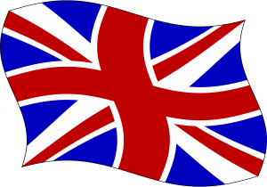

***Task 3***

Why do you think has society changed? Why are societies different?

**Identity**

**Identity**

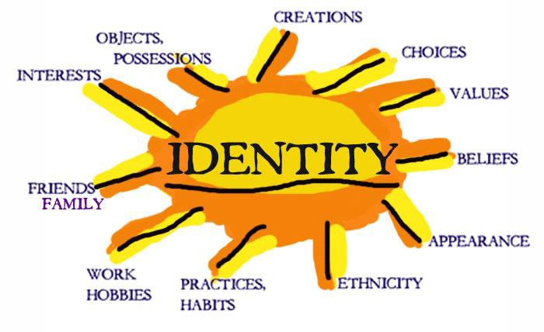Who are you? Are you part of a group, an individual, a student, a brother, a sister? Identity is about how we see and define ourselves and how other people see us and define us. Many aspects of our individual identity are influenced by **agencies of socialisation**. These are structures or groups of people.

***Task 4***

Suggest four examples of structures or groups of people that impact upon you:

1.

2.

3.

4.

***Nature vs Nurture – The Big Debate***



There are many ways of explaining why certain people do things in certain ways. For example, biologists think that people behave as they do because they are controlled by nature. This is known as **Nature theory**. Humans are compared to animals and seen to act on **instinct**.

Sociologists believe that people behave as they do because they are taught how to behave. For example, the sociologist Michael Haralambos states, ‘Human beings learn their behaviour and use their intelligence whereas animals simply act on instinct.’ This is known as **Nurture theory**. Nurture means the way you are brought up. It is also a reference to **socialisation**, the lifelong process by which we learn our culture, values, norms and how to behave.

***Task 5***

Write down a list of things that you were taught by other people about how to behave e.g. how to speak etc.

1. 4.

2. 5.

3.

Sociologists reject nature theories for two particular reasons. If people behaved as they do because of nature, they would all act the same as each other. The following reasons show why people do not all act the same:

1. ***History***: people acted differently in the past from the way that they do today. They had different ideas and different beliefs.
2. ***Anthropology:*** this is the study of different human societies. Wherever you go in the world, people act differently from the way they do in Britain.

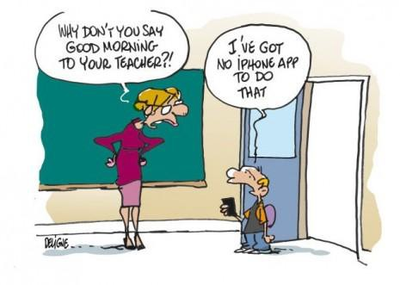**Social behaviour and culture**

Sociology is the study of human groups and social life in modern societies. Sociology recognises that as members of society we have to learn social behaviour and this is done through a variety of social institutions and social groups right throughout our lives.



***Task 6***

WHAT MAKES US HUMAN?

* *Are we meant to live alone?*
* *What would a person be like if they grew up without human contact?*
* *What would a person be like if they were then introduced into a society?*
* *Do we need a society in which to survive?*
* *Can someone be truly human if they grew up without human contact?*
* *Are we ruled by our instincts? (An instinct can be defined as a complex, unlearned pattern of behaviour that is universal in a species).*

**Watch the video and compare how, as children, we behave and how Oksana behaves. What has been the impact of the lack of human contact?**

<https://www.youtube.com/watch?v=nv3ocntSSUU>

It should have become clear that humans, more than most other animals, are dependent upon other humans for the most basic needs such as food and shelter.

We do not arrive in this world equipped with a collection of instincts inherited from our parents that will enable us to survive in a potentially hostile environment.

Virtually all the things that we do have to be learned from others, for example walking, speaking, knowing what to eat, defending ourselves etc. A desert island baby is unlikely to survive; therefore, we need other people.

We have now established an important principle. Human behaviour is largely learned through a process called ***socialisation.*** Therefore, what is termed as **culture,** which is our way of life, including the ways in which we behave relates to:

- the language we speak

- the clothes we wear

- the food we eat and whether we eat it with knives, forks and spoons

- the homes we live in

- to the things we believe about the origins of life

- what is good or bad

- or the ways in which we should be governed.

The above are all acquired from other people (this involves the process of **socialisation** into the **culture** of our society)

It is through our membership of social groups that we acquire an understanding of the ways in which behaviour is patterned and organised and of the **values**, customs, **norms** and **roles** of our society. Sociologists refer to this as **culture** — the learned, shared behaviour of members of society. Culture is a social blueprint, a guide for living. It refers to all the aspects of human behaviour that are learnt rather than genetically transmitted.

* **Norms** are social rules which define correct and acceptable behaviour in a society or social group to which people are expected to conform.
* **Values** are less specific than norms. They are general guides for behaviour. Values are ideas and beliefs about what is ‘right’ and ‘wrong’ and about standards which are worth maintaining and achieving in any society.

***Task 7***

How would you describe British culture? Try to refer to some of the terms in bold above.