Flying Start to Psychology

Task 1: Career pathways and wider understanding .  
_________________________  
  
Task 2 – What will you learn in A-Level Psychology?

_________________________  
  
Task 3 - Reviewing key terms from GCSE science.  
_________________________  
  
Activity 4 - Learning about research methods used in psychology.  
_________________________  
  
Activity 5 - reviewing understanding of relevant GCSE biology topics.  
_________________________  
  
Activity 6- reviewing GCSE maths knowledge.  
_________________________  
  
Activity 7 - Introduction to some A-Level Psychology topic areas.

Task 1

Professional body The British Psychological Society represents psychology and psychologists in the UK. The Society has a number of divisions, each dedicated to a specific area of psychology. It is also responsible for ethical practice.

**Task 1: Career pathways and wider understanding**

A-Level Psychology is useful (but not required!) for a degree in Psychology or the related fields of Anthropology, Counselling, Criminology, Neuroscience, Occupational Therapy, Forensic Science, Sociology and Teaching.

A degree in Psychology is the first step to a career as a Chartered Psychologist (Clinical,

Educational, Occupational, Forensic, Sport or Teaching and Research).

a) Read about careers in psychology on the BPS website [Find your career in psychology | BPS](https://www.bps.org.uk/find-your-career-psychology)

b) Explain which area/career inspires you the most and why.

**Task 2**

What will you learn in A-Level Psychology?

You will develop psychological knowledge, understanding and skills by learning the AQA A-Level Psychology specification (link below, but we will give you clear topic area checklists for each topic that you study)

[AS and A-level Psychology Specification Specifications for first teaching in 2015 (aqa.org.uk)](https://filestore.aqa.org.uk/resources/psychology/specifications/AQA-7181-7182-SP-2015.PDF)

We will go beyond this specification (in class and through extra-curricular opportunities) to prepare you more widely for the next steps in your education and employment. For example, we will develop your understanding of your own brain and mental processes and how to learn and teach effectively. We will also explore a few of the most recent psychological research findings and enable you to search for and read journal articles.

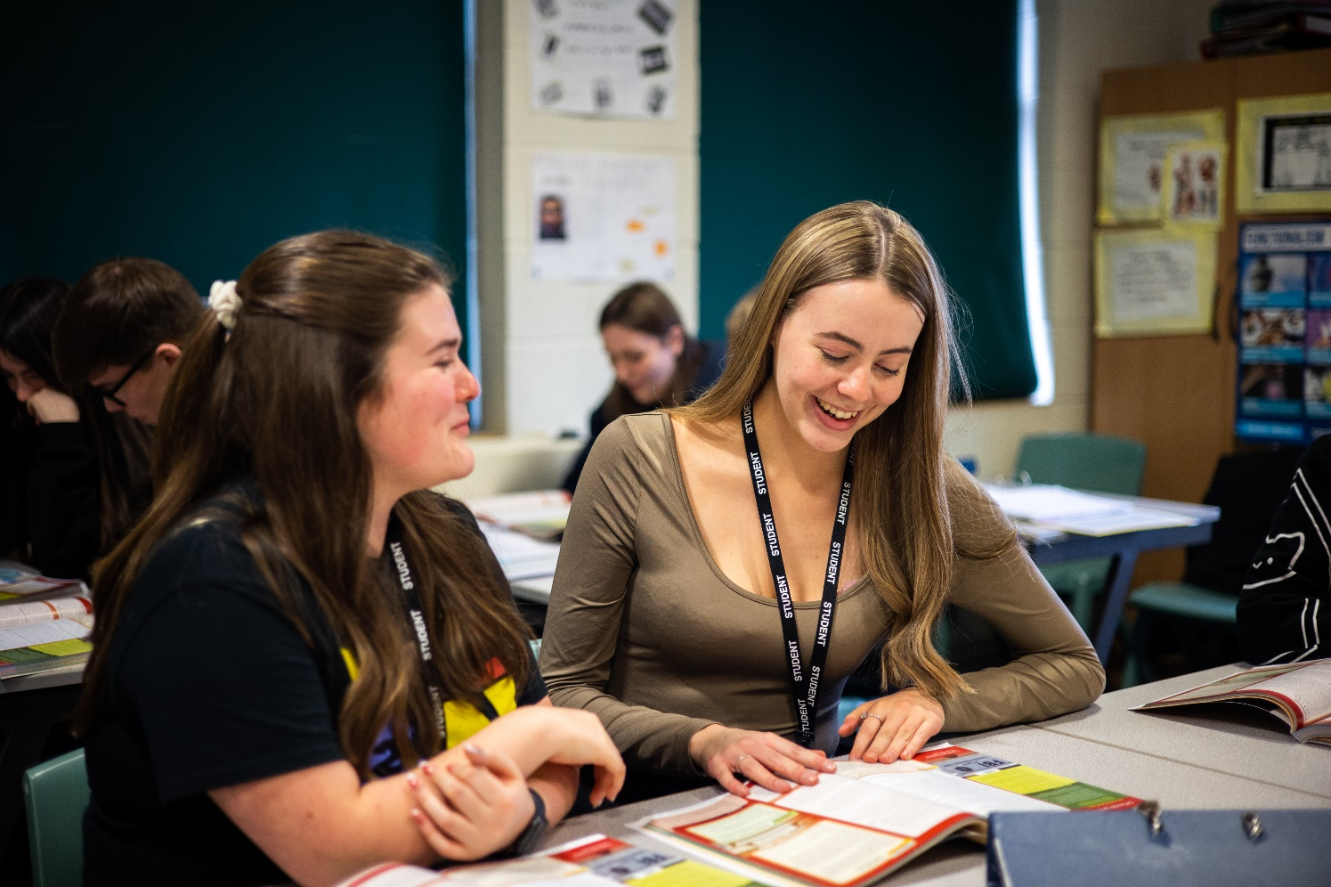

What do you already know about Psychology?

Whether you have studied psychology at GCSE level or you are studying the subject for the first time at A-Level (as is the case for most students), you already have some psychological knowledge, understanding and skills. This is because A-Level Psychology is a science and builds on some of the concepts, ways of thinking and skills you developed studying GCSE Science (particularly Biology) and Maths. For example, you will build upon the ability you acquired at GCSE to evaluate claims based on science through critical analysis of the methodology, evidence and conclusions.

**Task 3 - Reviewing key terms from GCSE science**

Let’s have a look at some of the terminology you have from GCSE science that you will go on to use in A-Level Psychology. *Don’t worry if some of the terms are unfamiliar – we will be covering them all during the course.*

Fill in the grid below.

|  |  |  |
| --- | --- | --- |
| GCSE Science Term | Definition from Memory | Check your knowledge.  Review your GCSE Science exercise books or use the websites below to check your definition |
| Hypothesis |  |  |
| Dependent variable |  |  |
| Independent variable |  |  |
| Control variable |  |  |
| Cause and effect |  |  |
| Objectivity |  |  |
| Peer review |  |  |
| Quantitative date |  |  |
| Qualitative data |  |  |
| Sampling techniques |  |  |
| Representativeness |  |  |
| Accuracy |  |  |
| Precision |  |  |

[Practical Skills - Practical skills - GCSE Combined Science Revision - CCEA Double Award - BBC Bitesize](https://www.bbc.co.uk/bitesize/guides/zh94y9q/revision/1)

[Population and sampling - Collecting data - AQA - GCSE Maths Revision - AQA - BBC Bitesize](https://www.bbc.co.uk/bitesize/guides/zwcw6yc/revision/4)

[Carrying out an experiment - Carrying out an experiment (CCEA) - GCSE Combined Science Revision - CCEA Double Award - BBC Bitesize](https://www.bbc.co.uk/bitesize/guides/zkx2kmn/revision/1)



**Activity 4 - Learning about research methods used in psychology**

Throughout your time studying science you have also developed experimental skills and strategies, having planning experiments to make observations, test hypotheses or explore phenomena.

1. What can you remember about the experimental method?

The experimental method is also used in psychology. However, the complex nature of studying the brain, mental processes and behaviour means that psychologists may also use non-experimental methods. Both experimental and non-experimental methods have strengths and limitations. You have learnt about another of these research methods, correlation, in maths and will be able to build on this knowledge here.

|  |  |
| --- | --- |
| Research Methods | |
| Experimental Method | Observation  Self Report  Correlation  Case study |

Create revision notes on research methods using the links below to help you.

1) Crash course psychology https://www.youtube.com/watch?v=hFV71QPvX2I

2) https://www.simplypsychology.org/research-methods.html (see the menu down the right side of the page)

3) If you would like to hear an explanation about each method visit Psychboost https://www.youtube.com/watch?v=whwwoCI57nw&list=PLUQ8QDGvbAwhFY-fZkcJ3k4R2NCnZlqB4 and see the remaining methods down the right-hand side of the screen.

1. d) **Create a flashcard on each of the five methods.** You could do this electronically, online using https://quizlet.com/89313049/what-is-quizlet-flash-cards/ or by hand.

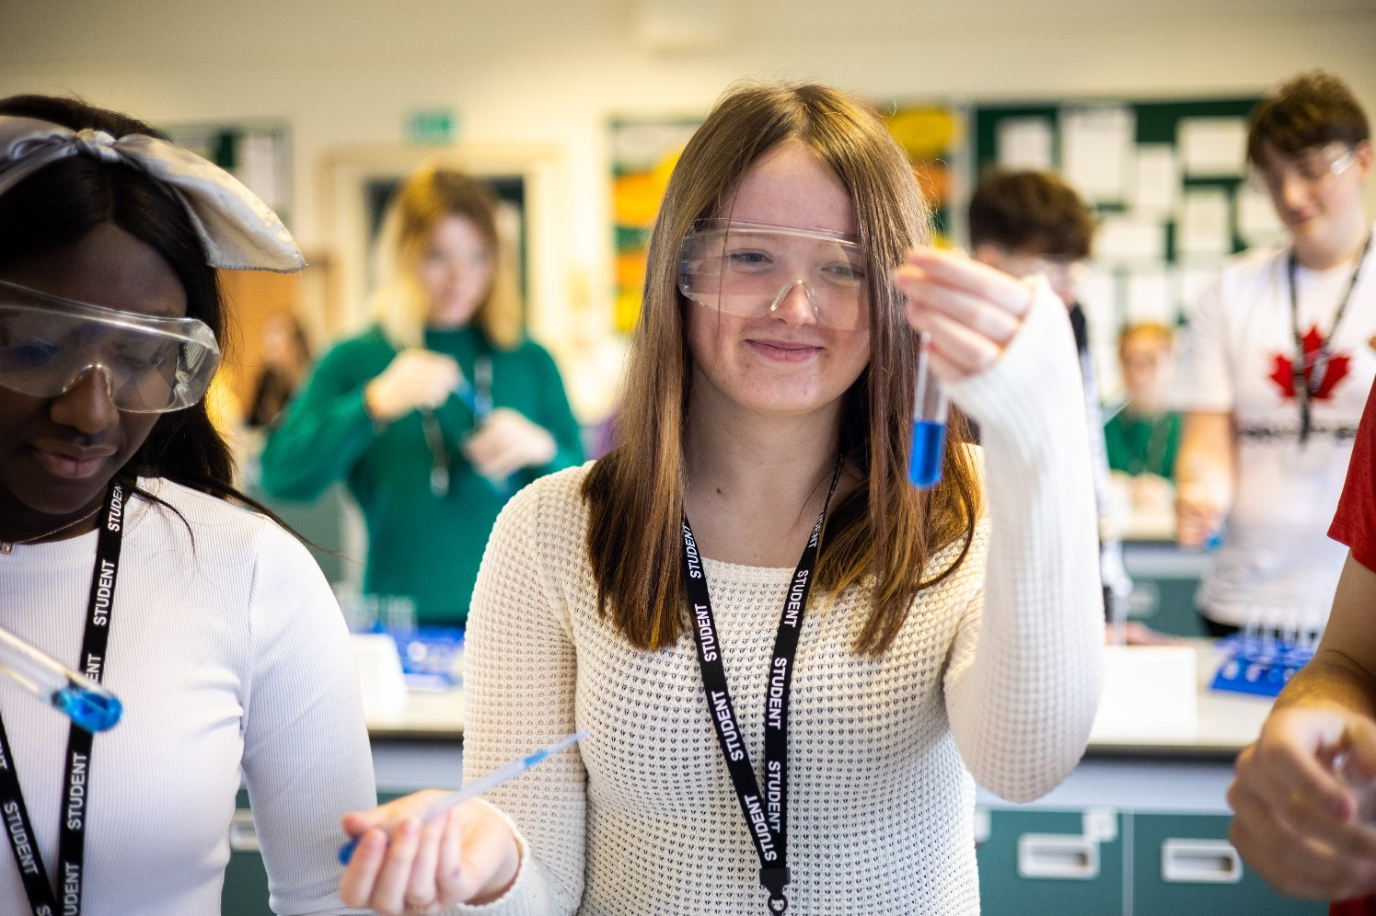

**Activity 5 - reviewing understanding of relevant GCSE biology topics**

You already have detailed knowledge of many aspects of the biological approach and the wider biopsychology topic from the GCSE biology course. Specifically, the ‘Coordination and control’ and the ‘Evolution, inheritance and variation’ topics.

The specific elements of each of these GCSE biology topics that you are required to know and understand for the A-Level Psychology specification are:

|  |  |
| --- | --- |
| **Coordination and control** | **Evolution, inheritance and variation** |
| **•** principles of nervous coordination and control in humans  • the relationship between the structure and function of the human nervous system  • the relationship between structure and function in a reflex arc  • principles of hormonal coordination and control in humans  • hormones in human reproduction | • the genome as the entire genetic material of an organism  • how the genome, and its interaction with the environment, influence the development of the phenotype of an organism  • sex determination in humans  • the process of natural selection leading to evolution  • the evidence for evolution |

1. **a) What can you remember about the Coordination and Control topic?**
2. **b) Use your GCSE Biology notes / book /** https://www.bbc.co.uk/bitesize/guides/zg6xdxs/revision/1 pages 1, 2 and 4 / https://classroom.thenational.academy/units/homeostasis-and-response-1a15 **to create a revision resource covering the bullet points in the above table for the *Coordination and control* topic.** You could use Quizlet https://quizlet.com/89313049/what-is-quizlet-flash-cards/ or create a quiz. If you would prefer to create revision notes think about how you will do this (bullet points / paragraphs / tables / mind maps) and draw or insert images to help you remember key terms. If you make revision notes you could add to these when we study the topic.
3. **c) What can you remember about the *Evolution, inheritance and variation* topic?**
4. **d) Use your GCSE Biology notes / book /** https://www.bbc.co.uk/bitesize/guides/zyxm8mn/revision/1 **or https://classroom.thenational.academy/units/inheritance-variation-and-evolution-0224 to create a revision resource on each of the bullet points in the above table for the *Evolution, inheritance and variation* topic.** You could use Quizlet https://quizlet.com/89313049/what-is-quizlet-flash-cards/ or create a quiz. If you would prefer to create revision notes think about how you will do this (bullet points / paragraphs / tables / mind maps) and draw or insert images to help you remember key terms. If you make revision notes you could add to these when we study the topic.

**Activity 6- reviewing GCSE maths knowledge**

**What about maths?**

10% of the overall marks from the three psychology exams will assess your ability to meet the mathematical requirements of the A-Level psychology course (see the specification link given on page 5 if you would like full details). Whilst we will spend a significant amount of time supporting you to develop the understanding and skills required, you already have a great amount of knowledge!

1. **a) Have a look at the following list of mathematical concepts and self-evaluate your level of confidence with each one on a scale of 1-5 (where 5 = ‘I am very confident with this’).**
2. **b) Where you are less confident, use your My Maths account and / or the following BBC Bitesize maths website to consolidate your understanding:** https://www.bbc.co.uk/bitesize/examspecs/z8sg6fr (select the topic you wish to review).

*Don’t worry if some of the terms are unfamiliar – we will be covering them all during the course.*

|  |  |
| --- | --- |
| **Mathematical Concepts** | **Levels of Confidence** |
| **Probability** |  |
| **Ratio** |  |
| **Fraction** |  |
| **Standard form** |  |
| **Decimal form** |  |
| **Significant figures** |  |
| **Population and sample** |  |
| **Continuous and discrete data** |  |
| **Histogram** |  |
| **Bar chart** |  |
| **Measures of central tendency** |  |
| **Measures of spread** |  |
| **Calculating percentage (including increase / decrease)** |  |

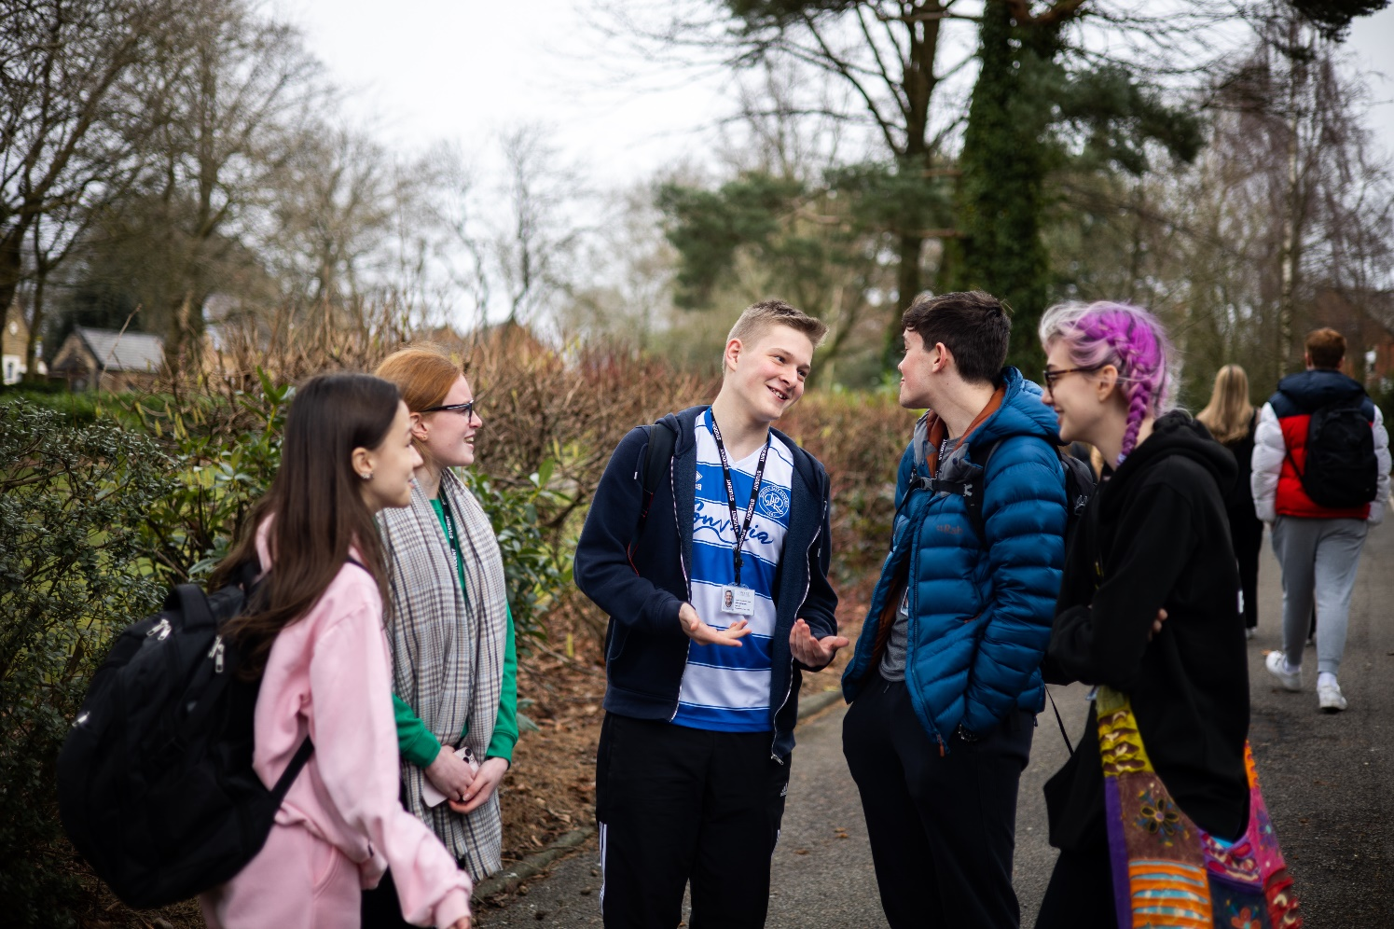

**Activity 7 - Introduction to some A-Level Psychology topic areas**

• **Option a) If you did not study GCSE Psychology**, watch the two videos below to introduce you to two more topic areas that you will study during your first year with us. Use the Cornell note taking system to make notes.

* 1. • **Option b) If you did study GCSE Psychology:** o Recall and write down as much information about the memory topic as you can
  2. o Watch the memory video.
  3. o Add to / correct your recall notes using a different colour.
  4. o How much did you remember? Why have you remembered somethings and not others? What does this suggest about how you learn?
  5. o Repeat the previous four steps for the social influence topic.
  6. • Memory:
  7. https://www.youtube.com/watch?v=bSycdIx-C48&list=PL8dPuuaLjXtOPRKzVLY0jJY-uHOH9KVU6&index=13

• Social influence:

* https://www.youtube.com/watch?v=UGxGDdQnC1Y&list=PL8dPuuaLjXtOPRKzVLY0jJY-uHOH9KVU6&index=38